Case 3-Asia-India-Harappa-Vase-2800-1800 BCE

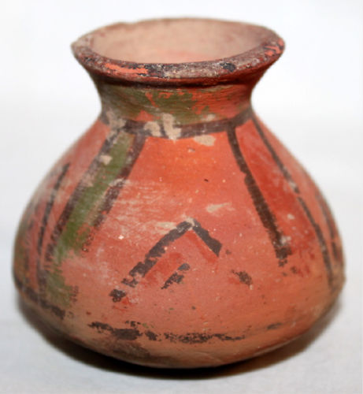

# ANCIENT